**MCQ based Academic Task-1**

**Course Code: INT306 Section: K20YR**

**Total time: 40 mins No negative marking**

**Date: 21-09-2021**

1. Which of the following command is correct if I want to modify the table name of Employee_Data to Emp_Data?

**a. RENAME Employee_Data to Emp_Data**

b. ALTER table Employee_Data modify Emp_Data

c. RENAME table Employee_Data to Emp_Data

d. ALTER Emp_Info modify Emp_Data

2. Ready the Query carefully:

SELECT emp_name

FROM department

WHERE dept_name LIKE ' _____ Computer Science';

In the above-given Query, which of the following can be placed in the Query's blank portion to select the "dept_name" that also contains Computer Science as its ending string?

a. &

b. _

**c. %**

d. $

3. In the following Query, which of the following can be placed in the Query's blank portion to display the salary from highest to lowest amount, and sorting the employs name alphabetically?

SELECT * FROM instructor ORDER BY salary ____, name ___;

a. Ascending, Descending

b. Asc, Desc

**c. Desc, Asc**

d. All of the above

4. ___ defines the number of tuples in a relation

a. Entity

b. Column

**c. Cardinality**

d. None of the above

5. In which one of the following, the multiple lower entities are grouped (or combined) together to form a single higher-level entity?

a. Specialization

**b. Generalization**

c. Aggregation

d. None of the above

6. The architecture of a database can be viewed as the ________

a. One level

b. Two-level

**c. Three-level**

d. Four level

7. The attribute AGE is calculated from DATE_OF_BIRTH. The attribute AGE is:

a. Singled value

b. Multi values

c. Composite

**d. Derived**

8**. Given the basic ER and relational models, which of the following is INCORRECT?**   
(A) An attributes of an entity can have more that one value   
(B) An attribute of an entity can be composite   
**(C) In a row of a relational table, an attribute can have more than one value**   
(D) In a row of a relational table, an attribute can have exactly one value or a NULL value

9. Consider the following ER diagram. The minimum number of tables needed to represent M, N, P, R1, R2 is ______.

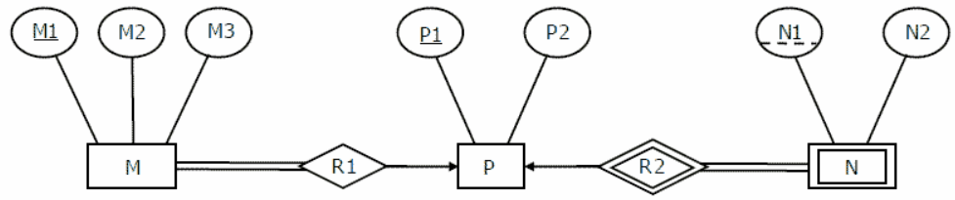

A. 2

**B. 3**

C. 4

D. 5

10. Drop Table cannot be used to drop a Table referenced by __________ constraint.

(i) Primary key

(ii) Sub key

(iii) Super key

(iv) Foreign key

A. i

B. i, ii and iii

**C. iv**

D. i and iv

11. Which of the following options are Right regarding these three keys (Primary Key, Super Key, and Candidate Key) ?

I. Only one candidate key can be a primary key

II. Minimal super key is a candidate key.

III. All super keys can be a candidate key

IV. We cannot find a primary key from the candidate key

**a. I and II**

b. II and III

c. I and III

d. II and IV

12. In which of the following cases a DML statement is not executed?

a. When existing rows are modified.

**b. When a table is deleted.**

c. When some rows are deleted.

d. When some rows are dropped

13. ______ is NOT a type of constraint in SQL language?

a. FOREIGN KEY

b. PRIMARY KEY

c. UNIQUE

**d. ALTERNATE KEY**

14. Which of the following is the right command if you want to display only the first 4 rows of the ‘Employee_Data’ table?

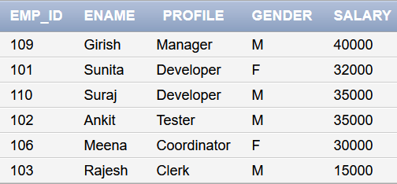

a. SELECT * from Employee_Data WHERE ROWNUMBER <= 4

b. SELECT * from Employee_Data WHERE ROW <= 4

**c. SELECT * from Employee_Data WHERE ROWNUM <= 4**

d. SELECT * from Employee_Data WHERE ROWS <= 4

15. Which of the following statement is true?

**a. TRUNCATE free the table space while DELETE does not.**

b. Both TRUNCATE and DELETE statements free the table's space.

c. Both TRUNCATE and DELETE statement does not free the table's space.

d. DELETE free the table space while TRUNCATE does not.